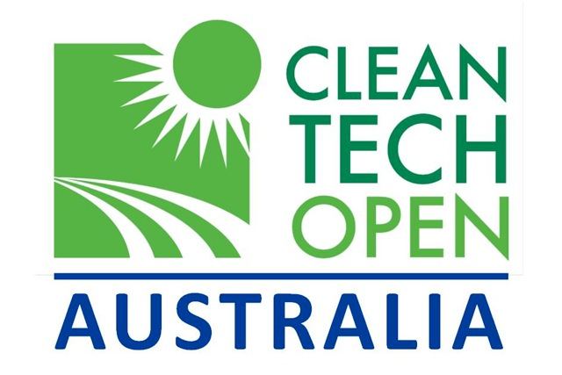

Media contact
ROTARY HEAT EXCHANGERS PTY LTD

ROTARY HEAT EXCHANGERS PTY LTD SELECTED AS A TOP 30 AUSTRALIAN CLEANTECH COMPANY IN NATIONAL COMPETITION

10 July 2012 – Rotary Heat Exchangers Pty Ltd today announced it has been selected as one of the top 30 cleantech companies in the Australian Clean Technologies Competition 2012 which is part of the international Cleantech Open competition. www.rotaryheatexchangers.com

Australian CleanTech Managing Director John O’Brien said the top 30 had been selected from a record field of 104 entrants that represents the best in Australian clean technology innovation and opportunity.

Company CEO Bill Ellul said “we are thrilled that the unique Australian technology originally developed by CSIRO is getting this recognition.”

The Australian Clean Technologies Competition, part of the Cleantech Open based in the USA, was launched by the Parliamentary Secretary for Industry and Innovation Mark Dreyfus in May.

Dr Marc Newson, Cleantech Supplier Advocate said, “Going by the calibre of entrants for this year’s competition, Australian cleantech is extremely well placed to prosper at home and in the global market. Some of the technologies on display are world-class.”

A judging panel comprised of experts in innovation and commercialization included:

- Geoff Hoffman, Clayton Utz

- Marc Newson, Cleantech Supplier Advocate

- David Clark, Phillips Ormonde Fitzpatrick

- Paul van Bergen, KPMG

- Ken MacLeod, Scoria Macleod

- Ben Wright, ATP Innovations

- Andrew Pickering, Cleantech Ventures

The 30 semi-finalists were chosen from a national field of entrants across the spectrum of clean technology activity, which includes transportation, smart power, green grid, energy storage, green building, renewable energy, energy efficiency, and air water and waste management.

The semi-finalists will join the Cleantech Business Accelerator Program, which includes individual mentoring to help with the development of their business plan; an intensive mentoring workshop; and the submission of a final business plan.

Up to six companies will then be selected as Finalists and will receive additional advice and introductions.

The Australian winner will be announced at an Investment Showcase and Gala Dinner in October 2012.

The winner will be funded to represent Australia at the international Global Cleantech Open Competition in the US in November 2012. All of the finalists will be invited to join the Australian delegation attending this event.

Rotary Heat Exchangers Pty Ltd www.rotaryheatexchangers.com.au
is
the only Australian manufacturer of RHEs,. and is 100% Australian owned The company was established in 1968 as a result of R&D conducted by CSIRO and Monash University following a world energy crisis.

It supplies high performance, long life Australian rotary heat exchangers for building air conditioning, indoor pool air heating and other industrial air heating applications, which out perform all other competitors. Their function is to substantially reduce energy running costs by recycling waste energy.

The substantial benefits to the environment from the resultant reduction in greenhouse gas emissions over the proven long life of the product over the long history of the company has been considerable.

About the Australian CleanTech Open www.cleantechopen.com.au

The Competition is an initiative of the Gillard Government’s $58.4 million Buy Australian at Home and Abroad initiative, and is supported by Enterprise Connect, Commercialisation Australia, CSIRO and Austrade. The competition is being managed by Australian CleanTech a private research and advisory business

About Australian CleanTech www.auscleantech.com.au

Australian CleanTech facilitates and delivers Australian Clean Technology projects on behalf of both investors and project proponents.
In addition, Australian CleanTech provides services to Government agencies to help stimulate investment in the Cleantech industry. To deliver these services Australian CleanTech uses its extensive Cleantech research database.
Australian CleanTech also provides access to the ACT Australian Cleantech Index. The emerging Cleantech sector covers a range of growth industries that will move the concept of sustainable living from theory and aspiration to a practical reality.
Through a range of publication and articles, Australian CleanTech provides educational resources to help raise the awareness of the sector.

